8-Band Backpack-style Drone Suppressor

Model No: TTSKM02
- Product Characteristics
- Using UHF broadband seamless jamming technology;
- Single switch control output, with battery power display;
- The higher the effective power (channel power), the greater the interference distance;
- Effective segmentation, only interfere with drone control and video transmission frequencies, will not interfere with other frequencies;
- Imported devices. The design of the slow start circuit can avoid the ignition phenomenon caused by the mechanical switch, and the integration is high and the work is stable;
- With built-in battery, battery life is about 1 hour, charging for 6 hours;
- Use 8 SMA/N type of directional antenna interface (400M / 500M / 900M / 1.2G / 1.5G / 2.4G / 5.2G / 5.8G)
- One power charging interface (DC28V IN)

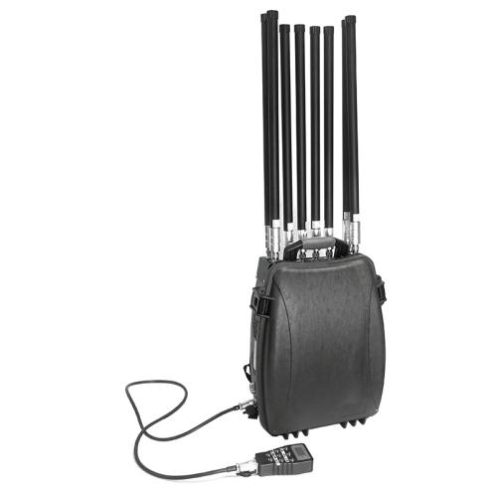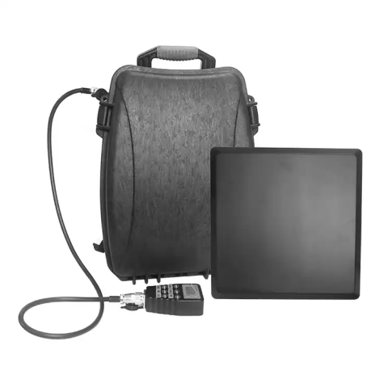

- Product Parameters
Frequency  (Customizable) | Working Frequency |  | dBm |  | Output Power
433MHz | 400-470MHz |  | 47dBm |  | 50W
500MHz | 480-525MHz |  | 47dBm |  | 50W
900MHz | 850-940MHz |  | 47dBm |  | 50W
1.2GHz | 1160-1280MHz |  | 47dBm |  | 50W
1.5GHz | 1550-1620MHz |  | 47dBm |  | 50W
2.4HGz | 2380-2500MHz |  | 45dBm |  | 30W
5.2GHz |  | 5150-5350MHz |  | 47dBm | 50W
5.8GHz |  | 5700-6000MHz |  | 45dBm | 30W
Power Supply: AC220V-DC24V
Omnidirectional countermeasures range: 500-1500 meters
Power Consumption: 360W
Weight: 16kgs Size: 370×240×510mm

- Product Operation Instruction
- Precautions
- Before using the device, please connect the antenna and tighten it accordingly.
- Please connect the handle one by one. After connecting the handle, the battery power on the handle displays the number of batteries inside the device, and the device can be charged at any time.
- When the device is in use, enable the fan heat dissipation system.
- This type of device is configured with both 28V DC and 220V AC. Please check and verify carefully before use.
- Avoid misconnection, burning module, etc.

- Use Process
- Forced landing of DJI drones: Please open 1.5G, 2.4G, 5.8G;
- Forced returning DJI drones: Please open 2.4G, 5.8G;
- Forced landing of lane passing drones: Please open 1.5G, 2.4G, 5.2G, 5.8G;
- Forced returning the passageway UAV: Please open 2.4G, 5.2G, 5.8G;
- 400M remote control is the remote control frequency band of homemade drones, TV remote control, car keys, children's toys like flying machines and so on;
- 900M remote control is a commonly used remote control frequency band for industrial drones, Police level, customized drones, large class drones, etc.
- 1.2G is China's self-developed Beidou navigation system, which will also be used in the UAV industry in the future, as the second positioning system of 1.5G (GPS), which is currently in the published data and will be used in the future.
Note: Whether the device is in use or not, please charge the device once every half month to ensure the performance of the battery.

According to the test standards of the Ministry of Public Security and depending on the actual situation, the distance between the drone and the remote control is 100 meters, and the countermeasure distance is about 1,000 meters.

Wireless communication must ensure sufficient carrier-to-dry ratio (signal-to-noise ratio) in order to effectively receive and complete communication. The communication signal jammer is to destroy the receiving conditions of the UAV by generating interference signals with the same frequency as the UAV, and cut off the communication connection between the UAV and the remote control transmission. To achieve the effect of interference communication.

The interference power is certain, and the shielding radius of the unblocked space is determined by the path attenuation and the control remote transmission signal level. The following table gives a comparison of distance and path attenuation. Then the coverage radius can be determined by the output channel power, remote control signal level and coverage line gain of the jammer. As follows:

Pch+Gat-L-FAF≥Prx

Pch : | Minimum channel power output of the jammer
Gat : | Antenna gain
L : | Path attenuation
FAF : | Path loss added value, take 6-8dB
Prx : | Received signal strength

Distance And Attenuation Comparison Table

L=32+ 20logd +20logf+ FAF

Distance（m） | 900MHz  attenuation  （dB） | 1575MHz  attenuation  （dB） | Distance（m） | 2400MHz  attenuation  （dB） | 5800MHz  attenuation  （dB）
1 | 38 | 44 | 25 | 66 | 72
2 | 44 | 50 | 30 | 67.5 | 73.5
3 | 48 | 54 | 35 | 69 | 75
4 | 50 | 56 | 40 | 70 | 76
5 | 52 | 58 | 45 | 71 | 77
6 | 53.5 | 59.5 | 50 | 72 | 78
7 | 55 | 61 | 60 | 73.5 | 79.5
8 | 56 | 62 | 70 | 75 | 81
9 | 57 | 63 | 80 | 76 | 82
10 | 58 | 64 | 90 | 77 | 83
15 | 61.5 | 67.5 | 100 | 78 | 84
20 | 64 | 70 | 200 | 84 | 90

Use the antenna to correspond to the center of the shielding area, as shown below:
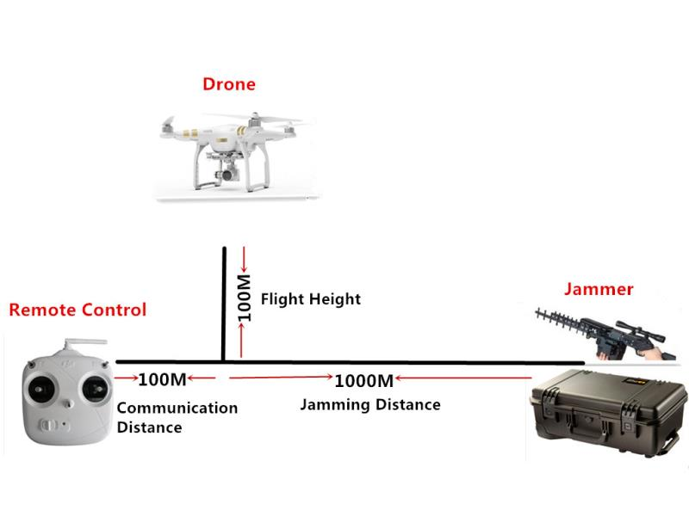
- The antenna must be connected before switching on the power supply. Do not remove the antenna when the host is working.
- Drone jammer equipment should be placed in a place with good ventilation, and try to avoid the occlusion of large objects to ensure the shielding effect.
- When using the shield outdoors, pay attention to waterproof and avoid exposure to the sun.
- The antenna should be used in a vertical direction towards the drone.

- FAQ
Q1: Is drone countermeasure equipment harmful to human body and mobile phone?
A: Please rest assured that the intensity of the emitted electromagnetic signal is very weak, and the test data show that the signal strength is far away
It poses no danger to human body. At the same time, only the interference of the forward signal, so that the UAV can not establish contact with the operating remote control, therefore, there will be no damage to the UAV itself.

Q2: Is there a difference in distance between indoor and outdoor use of drone countermeasures equipment?
A: Yes, generally speaking, outdoor signals use outdoor, so the indoor interference effect is poor. Strictly speaking: whether it is used indoors or outdoors; The effective working distance of the UAV interferometer has a certain relationship with the electromagnetic environment and the surrounding environment. Such as distance, location, etc.

Q3: The case of the UAV countermeasure equipment heats up after working for a period of time. Will it damage the machine if working for a long time?
A: This is a normal phenomenon. In design, we use the thermal conductivity of the all-aluminum housing to assist in heat dissipation. Thus, the machine can be guaranteed to work stably for a long time. Therefore, the case heating will not damage the machine.

